**Dojos & Ninjas with Template**

Objectives:

* Practice incorporating a one-to-many relationship in a full-stack application

Using the same project from the previous assignment, add a template and the necessary routes to perform these actions:

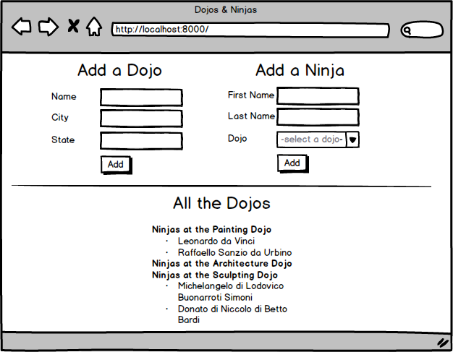

* Top of Form
* Add a template to your app
* Add a route that renders this template and have it display a list of all the dojos and their associated ninjas
* Add a route to process the creation of a new dojo
* Add a route to process the creation of a new ninja; the dropdown on the form should be a list of all existing dojos
* NINJA BONUS: Add a delete button next to each dojo name that deletes that dojo (and all associated ninjas) from the database
* SENSEI BONUS: Add a count of ninjas next to each dojo name (eg. Ninjas at the Painting Dojo - 2; Ninjas at the Architecture Dojo - 0)

Bottom of Form